Design section 2: Frameworks and tools
2.1 Frontend - React
Requirement 1.5.1 requires an intuitive and responsive interface, I believe using React for the frontend is a suitable framework to meet this requirement.
Since Requirement 2.1.2 requires collapsible sections, and the site is naturally modular because of its distinct sections, React’s component-based architecture makes it easy to implement, as well as maintain due to the natural encapsulation of each component.
React’s ability to easily update state makes it convenient whenever a user performs an action that changes something on the screen. Examples include:
- User uploading new replay (updating the list) (Requirement 1.1.1)
- User removing uploaded replay
- User choosing their rank (Requirement 1.1.8)
- User collapsing/expanding a section (Requirement 2.1.2)
- User choosing data category in Data Overview section (Requirement 1.2.6)
- User choosing what rank to compare data to and generating new spider charts in Rank Comparison section (Requirement 1.4.2)
Another reason to use React is it’s easy to integrate with Recharts to accurately and flexibly display different types of charts. Recharts is suitable because of its ease of integration with React, but also its support for bar charts and more crucially, spider charts.
An additional advantage with React is its popularity, since it means it is well-documented, and easy to find solutions to different problems during implementation as well as after, helping keep the website reliable throughout.
Component Hierarchy Charts:
The heading of each component is its name, while the list below it includes state and other possible fields, as well as their expected data types. The fields of the objects will be covered in future design sections.
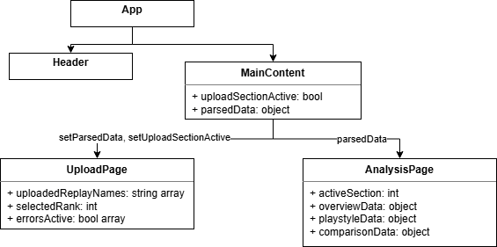
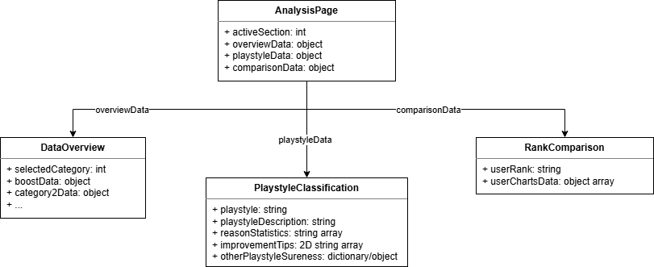
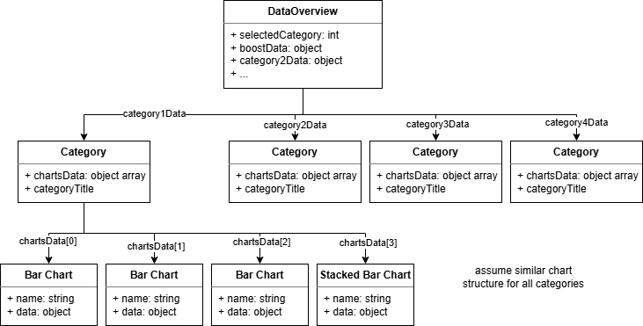
Note that number of charts, what type of charts, category names are not yet specified, this is a general structure.
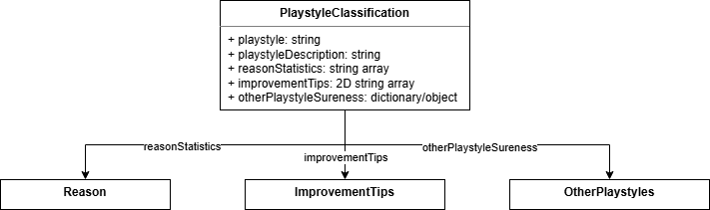
Note that since the data needed will be provided via props from PlaystyleClassification, there is no need to specify additional state for each child.
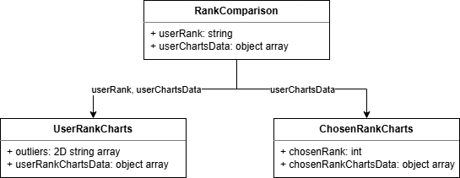

2.2 Backend - FastAPI

